**1. LIST THE BRANCHES HAVING SUM OF DEPOSIT MORE THAN 4000**

select bname,tot_amt from (select bname,sum(amount) as tot_amt from deposit group by bname)

where tot_amt > 4000;

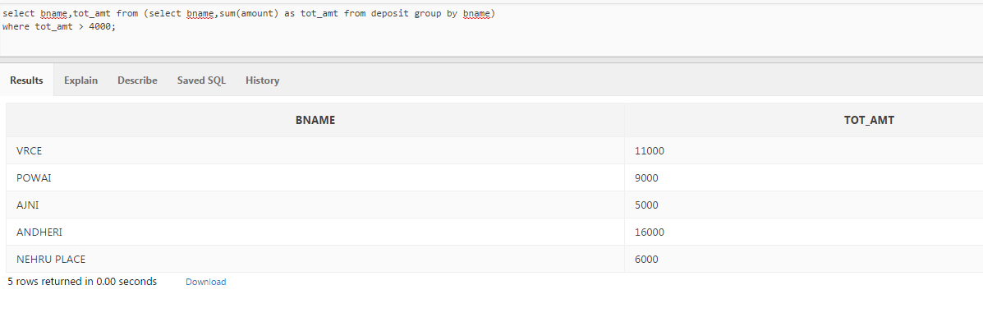

**2. LIST THE BRANCHES HAVING A SUM OF DEPOSIT MORE THAN 1000 AND LOCATED IN MUMBAI**

select b.bname,a.tot_amt from (select bname,sum(amount) as tot_amt from deposit group by bname) a,branch b

where a.bname=b.bname and tot_amt > 1000 and b.city = 'MUMBAI'

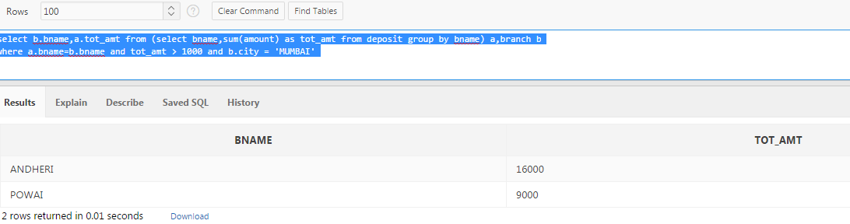

**3. LIST THE NAMES OF CUSTOMERS HAVING DEPOSIT IN THE BRANCHES WHERE THE AVERAGE DEPOSIT IS MORE THAN 1000**

select bname,cname,avg_amt from (select cname,bname,avg(amount) as avg_amt from deposit group by bname,cname)

where avg_amt > 1000;

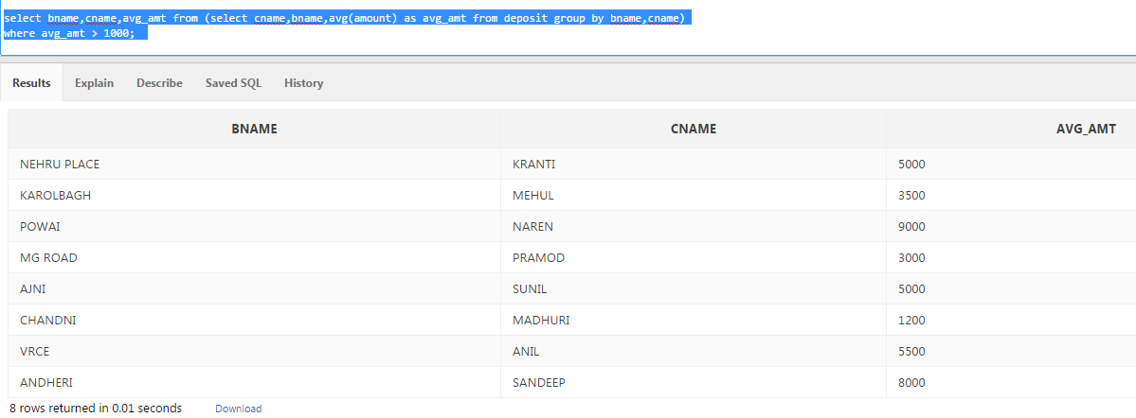

**4. LIST THE NAMES OF CUSTOMERS HAVING MAXIMUM DEPOSIT**

select b.cname,b.bname from (select max(amount) max_deposit from deposit) a,deposit b where a.max_deposit = b.amount;

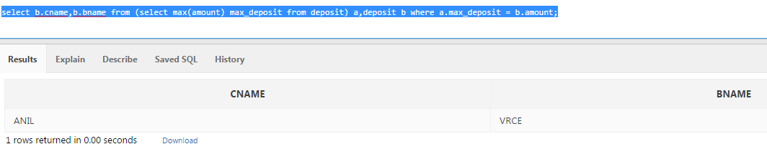

**5. LIST THE NAMES OF CUSTOMERS HAVING MAXIMUM DEPOSIT IN THE CUSTOMERS LIVING IN NAGPUR**

select distinct cname,b.city from deposit a,branch b

where b.bname=a.bname

and b.city = 'NAGPUR';

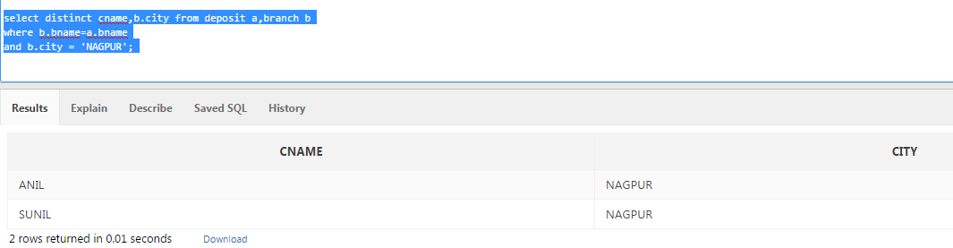

**6. LIST THE NAME OF BRANCH HAVING HIGHEST NUMBER OF DEPOSITORS**

select bname from (select bname,count(cname) as max_cust_no from deposit group by bname) max_val

where max_cust_no in (select max(max_cust_no) from(select bname,count(cname) as max_cust_no from deposit group by bname));

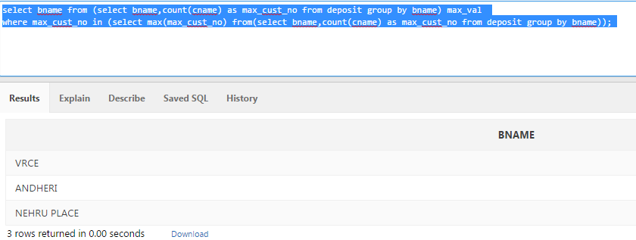

**7. COUNT THE NUMBER OF DEPOSITORS LIVING IN NAGPUR**

select count(cname) from deposit where bname in (select bname from branch where city = 'NAGPUR')

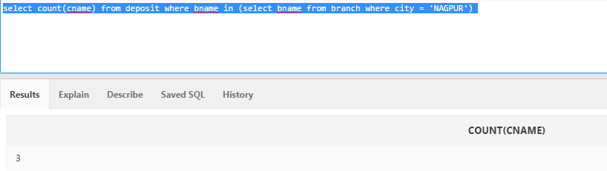

**8. LIST NAMES OF CUSTOMER IN POWAI BRANCH HAVING MORE DEPOSIT THAN ALL CUSTOMER FROM VRCE BRANCH**

select cname from deposit where bname = 'POWAI' and amount > (select sum(amount) max_dep from deposit where bname = 'VRCE' group by bname)

**9. LIST NAMES OF CUSTOMERS IN KAROLBAGH BRANCH HAVING MORE DEPOSIT THAN ANY OTHER CUSTOMER IN VIRAR BRANCH**

select cname from deposit where bname = 'KAROLBAGH' and amount > ANY (select amount from deposit where bname = 'VIRAR')

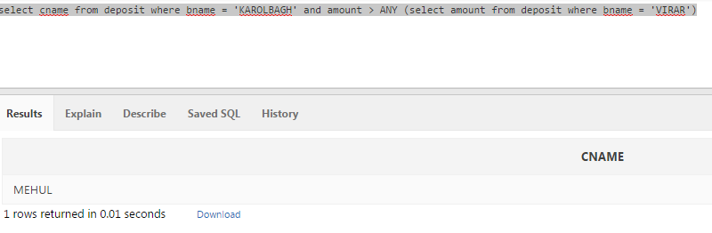

**10. LIST NAMES OF CUSTOMERS HAVING HIGHEST DEPOSIT IN THE BRANCH WHERE SUNIL IS HAVING DEPOSIT**

SELECT CNAME,MAX(AMOUNT) FROM DEPOSIT WHERE BNAME = (SELECT BNAME FROM deposit WHERE CNAME = 'SUNIL') GROUP BY CNAME;

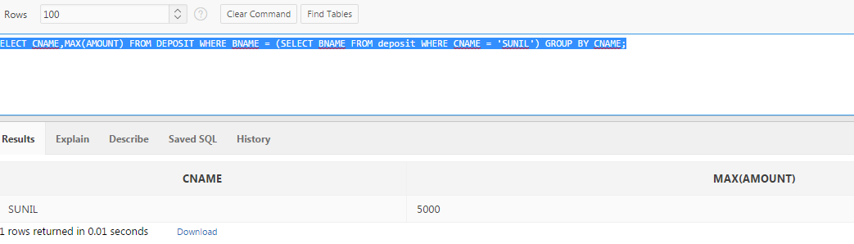

**12. List Names of Customers Having More Deposit than the Average Deposit in their respective Branches.**

select a.cname from (select cname,bname,sum(amount) tot_dep from deposit group by cname,bname) a,

(select bname,avg(amount) avg_amt from deposit group by bname) b

where a.bname=b.bname and

a.tot_dep > avg_amt;

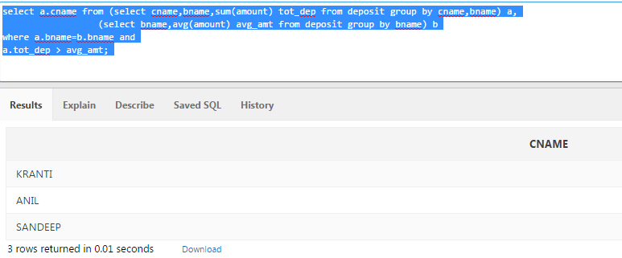

**13. List Names of Customers Having Maximum Deposit Among Deposits of NAGPUR for the VRCE Branch**

select max(abc.tot_amnt), abc.cname, abc.bname from

(select d.cname, b.bname, sum(d.amount) tot_amnt from deposit d,branch b

where b.bname = d.bname and city = 'NAGPUR'

and b.bname = 'VRCE'

group by d.cname, b.bname) abc

group by abc.cname, abc.bname

select cname,bname,max(amount) from deposit where bname = 'VRCE' group by bname,cname;

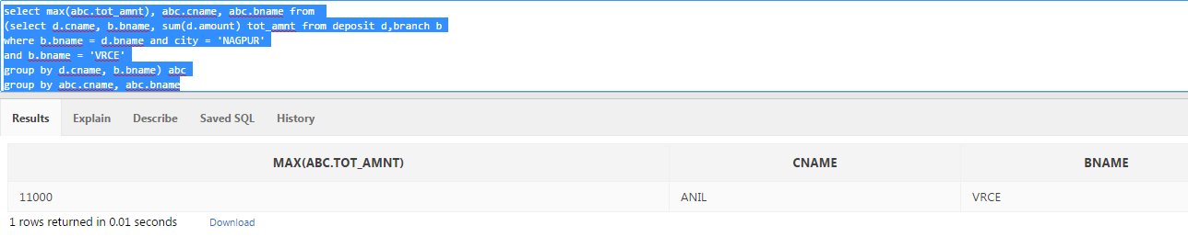

**14. List the Name of the Branch where Number of Depositors is Less than 2**

select bname from (select bname,count(cname) cnt from deposit group by bname) a where a.cnt < 2;

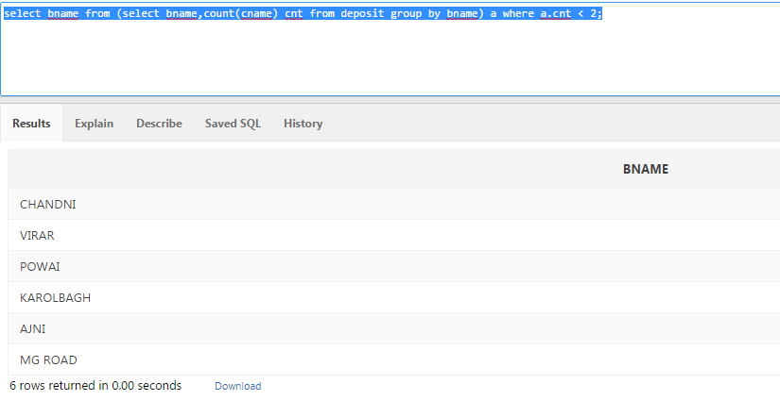

**\*\*15. List the Name of the City having more Customers living than in Nagpur**

**\*\*15. List the Name of the City having more Customers than living in Nagpur**

select city from (select bname from (select city,count(cname) cnt_nag from cust group by city having city = 'NAGPUR') a,

(select bname,count(cname) cnt_cust from deposit group by bname) b

where cnt_nag <= any cnt_cust) c,branch d

where c.bname = d.bname;

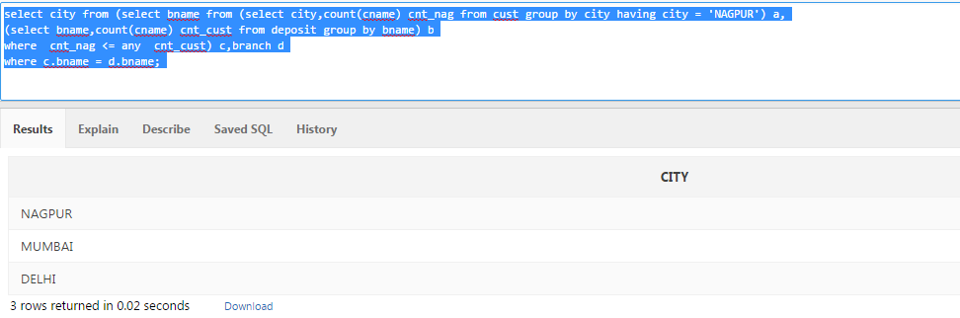

**16. List Names of Branches having the number of Depositors more than the number of Borrowers**

select a.bname from (select bname,count(cname) cnt_dep from deposit group by bname) a,

(select bname,count(cname) cnt_borr from borrow group by bname) b

where a.bname=b.bname

and cnt_dep > cnt_borr;

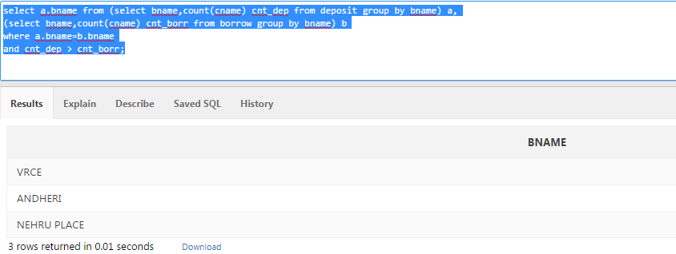

**17. List the Names of cities in which the maximum number of branches are located**

select city from (select city,count(bname) cnt_city from branch group by city) a

where cnt_city = (select max(count(bname)) from branch group by city);

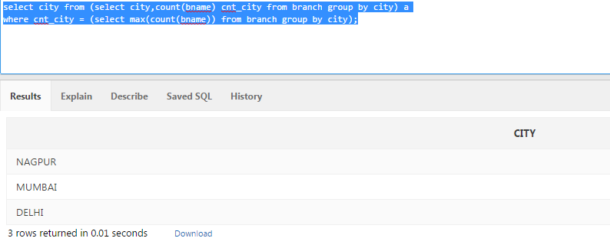

**18. List the Names of Customers Living in the City where the Maximum Number of Depositors are Located**

with cust_cnt as

(select city,sum(cnt_dep) tot_cnt from (select bname,count(cname) cnt_dep from deposit group by bname) a, branch b

where a.bname = b.bname

group by city)

select city from cust_cnt where tot_cnt=(select max(tot_cnt) from cust_cnt);

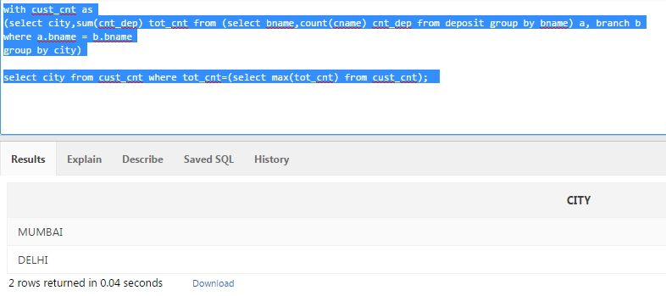

**19. List the Names of Borrowers Having the Same Branch City as the Highest Borrower**

with max_borrow as

(select borr.cname,borr.bname,b.city,borr.amount from borrow borr,branch b

where borr.bname = b.bname)

select mb.cname,mb.bname,mb.city from max_borrow mb

where mb.city=(select mb1.city from max_borrow mb1 where mb1.amount = (select max(sum(mb2.amount)) from max_borrow mb2 group by mb2.cname));

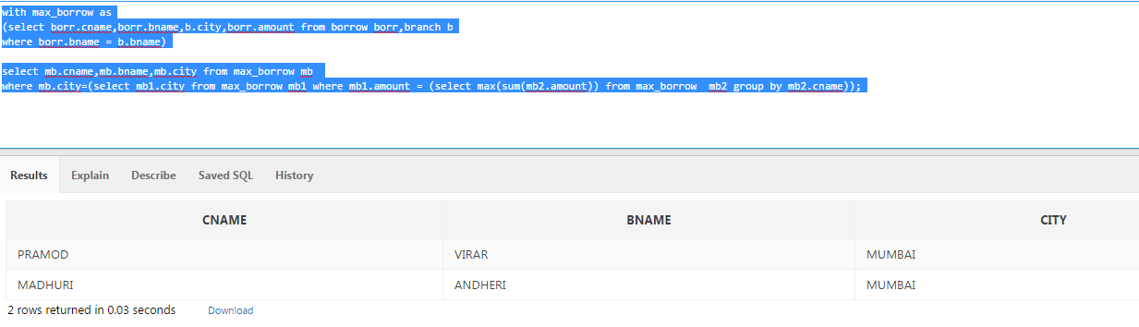

**20. Count the Number of Customers living in the City where Branch is Located**

with customer as

(select distinct b.city from branch b,cust c

where b.city=c.city)

select c1.city,count(c1.cname) cust_cnt from customer cu,cust c1

where cu.city=c1.city

group by c1.city;

